(option 1)

The crash-free energy drink straight from Mother Nature.

Dominate your workouts and your workdays

BeetBoost concentrates 2 body-revving superfoods in one convenient pack: beets for energy and endurance, plus tart cherries for muscle and joint health.

Fuel smarter and go longer. Never feel a crash – ever. See how it works >>

|  |  |
| --- | --- |
| **For athletic performance** | **For everyday health** |
| * Boosts endurance * Boosts focus * Boosts soreness relief * Boosts mental clarity * Boosts muscle and joint recovery | * Boosts energy levels * Boosts detoxification * Boosts immune support * Boosts cardiovascular support * Boosts overall health |

100% pure power juice

BeetBoost gives you all of the goodness of juicing, without the mess. If you ever juiced a beet, you know what we mean. So stop staining your fingers and grab BeetBoost instead.

Each portable pouch gives you the health-lovin’ nutrients of up to 6 medium-sized beets and a bowl full of antioxidant-packed tart cherries. Just add water for instant goodness. See health benefits >>

Only the good stuff. None of the bad.

* Non-GMO
* Gluten-free
* Vegan
* No preservatives
* No artificial or other sweeteners
* No fillers
* No added flavors
* 100% concentrated beet and tart cherry juices

No grit, just tasty. Guaranteed. See more advantages >>

***BeetBoost has given me renewed energy***

“I am 88 and a long-term cardiac patient. I could not walk, drive, or do mild exercise without getting physically and mentally exhausted and having serious shortness of breath. BeetBoost has given me renewed energy and now I can go grocery shopping and do regular exercise twice daily—all without exhaustion, mental or physical, or breathing problems." - Walter Manchur, Ashland, OR

***Energy went straight to my legs***

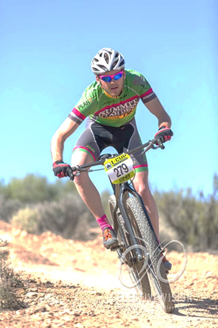"[With BeetBoost] energy went straight to my legs. They could push just a little longer. I did feel a higher sense of mental clarity. My focus was improved. I felt like I could go just as hard the next day.” - Jason Christiansen, Mountain Bike Racer, Lindon, UT

See more raves >>